

Practices for Secure Software Report

Table of Contents
Document Revision History 3
Client 3
Instructions 3
Developer 4
1. Algorithm Cipher 4
2. Certificate Generation 4
3. Deploy Cipher 4
4. Secure Communications 4
5. Secondary Testing 4
6. Functional Testing 4
7. Summary 4
8. Industry Standard Best Practices 4

Document Revision History

Version | Date | Author | Comments
1.0 | August 17, 2024 | Engred Vanegas

Client



Instructions

Submit this completed practices for secure software report. Replace the bracketed text with the relevant information. You must document your process for writing secure communications and refactoring code that complies with software security testing protocols.

- Respond to the steps outlined below and include your findings.
- Respond using your own words. You may also choose to include images or supporting materials. If you include them, make certain to insert them in all the relevant locations in the document.
- Refer to the Project Two Guidelines and Rubric for more detailed instructions about each section of the template.

Developer
Engred Vanegas

Algorithm Cipher

- High-level overview of the encryption algorithm cipher:
The encryption algorithm cipher that I chose to use for this project is the Advanced Encryption Standard (AES). I chose AES because it is a symmetric key algorithm that is widely recognized for three main things – its security, efficiency, and performance. This is precisely why it has become the most widely used and recognized encryption standard for securing sensitive data. More precisely, I chose AES-256, as will be explained below.
- Hash functions and bit levels of the cipher:
AES supports three key sizes – 18, 192, and 256 bits. These provide varying levels of security of course. Because AES does not have hash functions, however, it is often paired with SHA-256 in order to ensure both data integrity, and password key generation. This unique combination, of a strong hash function and AES is what enhances security in the end.
- Use of random numbers, symmetric versus non-symmetric keys:
As mentioned above, AES-256 is a symmetric key algorithm, meaning that it uses symmetric keys. This simply means that the same key is used for both the encryption and decryption processes. Key secrecy is crucial here and this is what AES’s security precisely relies heavily on. As a result, AES-256 uses an Initialization Vector (IV) in order to prevent the reuse of such keys and also to ensure that no identical plaintext blocks are the same, instead they encrypt to different ciphertext blocks. This is carried out by a random IV number that changes with each encryption operation, and thus enhancing security through the addition of randomness, as this helps ensure that the keys remain unpredictable at all times. In other words, all of this to say that this process ensures that even if the same data is encrypted multiple times, it doesn’t matter because the output will differ each time, and thus adding a layer of unpredictability and security. Non-symmetric keys on the other hand, use a pair of both public and private keys to encrypt and decrypt data.
- History and current state of encryption algorithms:
As mentioned above, AES is the now the selected encryption standard as established by the National Institute of Standards and Technology (NIST) back in 2001. It replaced the older Data Encryption Standard (DES) because DES was vulnerable to brute-force attacks. As a result, AES-256 is now the most widely used encryption standard throughout various security protocols such as TLS/SSL for the purpose of securing web communications and to protect sensitive data that is both in transit and at rest. Not to mention, that when used and implemented correctly, it hasn’t been able to be broken so far.

Certificate Generation
Insert a screenshot below of the CER file.

CER file Screenshot:
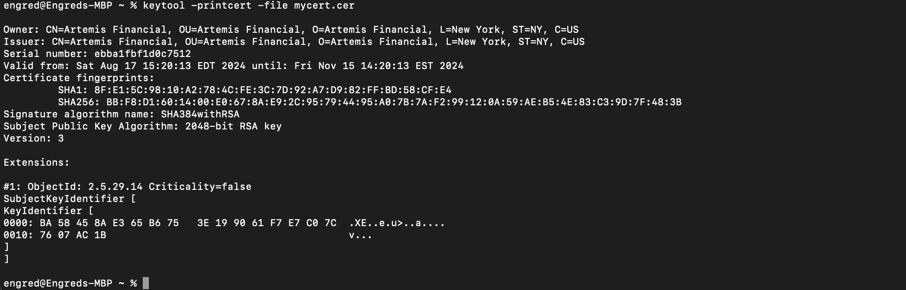
Certificate Form Creation:
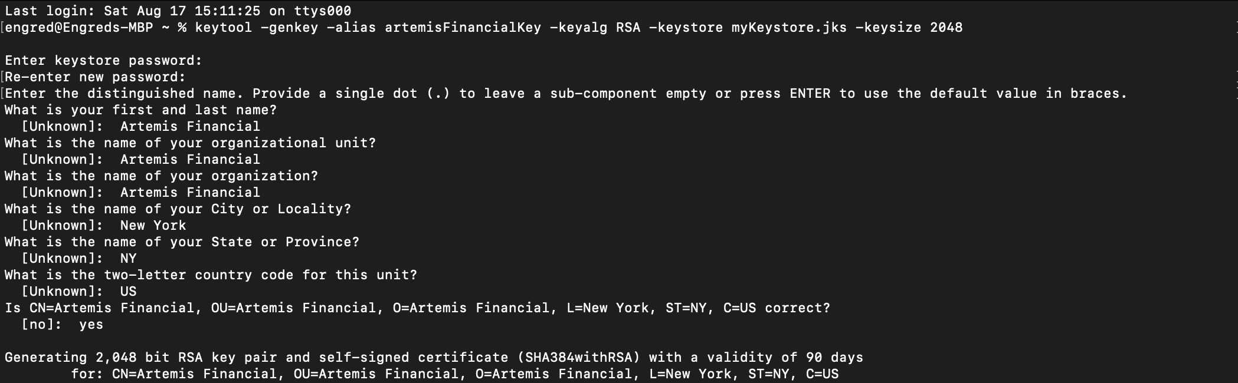
Exporting Certificate:

Deploy Cipher
Insert a screenshot below of the checksum verification.

Checksum Verification on port 8080:
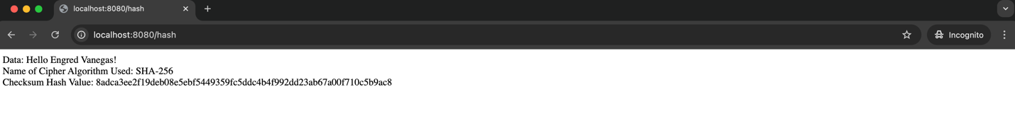

Checksum Verification on port 8443:

Secure Communications
Insert a screenshot below of the web browser that shows a secure webpage.

Secure Communications in Safari (padlock is seen – confirming connection is secure):
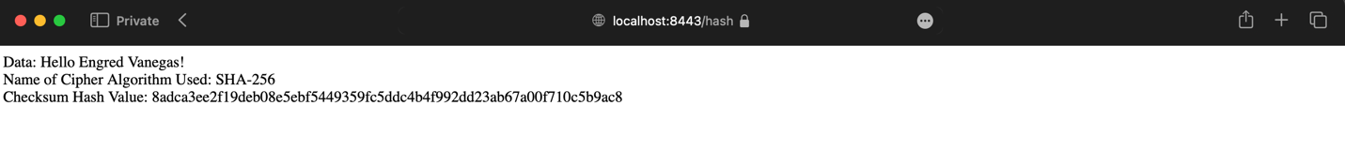

Secure Communications in Safari – Certificate (Clicked on ‘Show Certificate’ as evidence of self-signed root certificate):
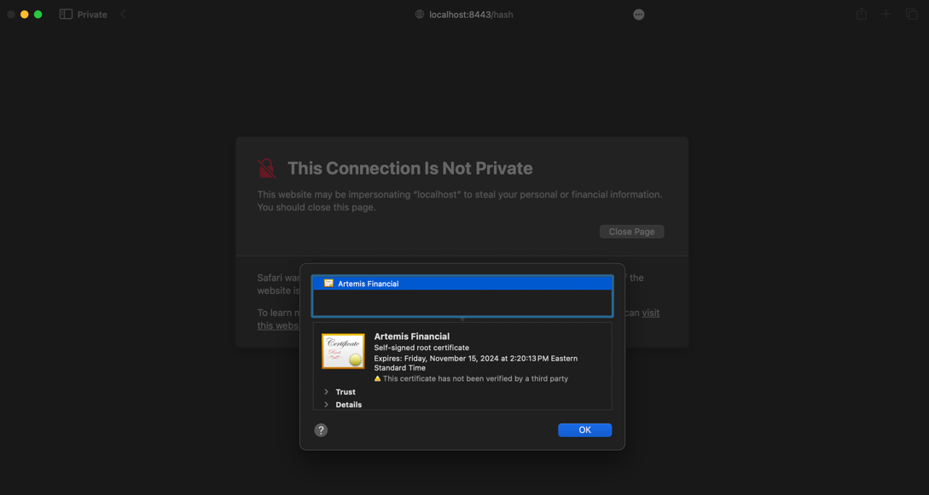
Secure Communications in Chrome (Showed as not secure since it doesn’t trust the self-signed root certificate):

Secure Communications in Chrome (Clicked on ‘Certificate View’ to show evidence of self-signed root certificate):
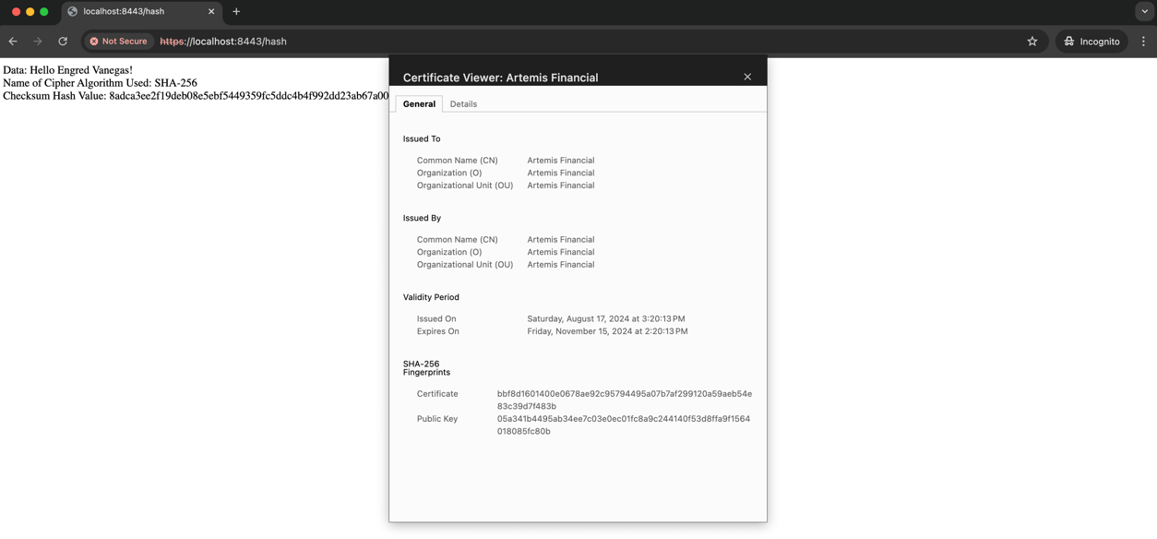
However, as seen in Safari, the communication is indeed secure and is loading over HTTPS but unfortunately in Chrome since this browser is not trusting the self-signed certificate it will still show the insecure warning. So, we proceed by bypassing the warning and making sure the information does load over HTTPS and since it does, and with the padlock showing in Safari, it is safe to say that the secure connection (HTTPS) is correctly set up and the communication is indeed encrypted as expected.

Secondary Testing
Insert screenshots below of the refactored code executed without errors and the dependency-check report.

- Screenshot of the refactored code executed without errors:
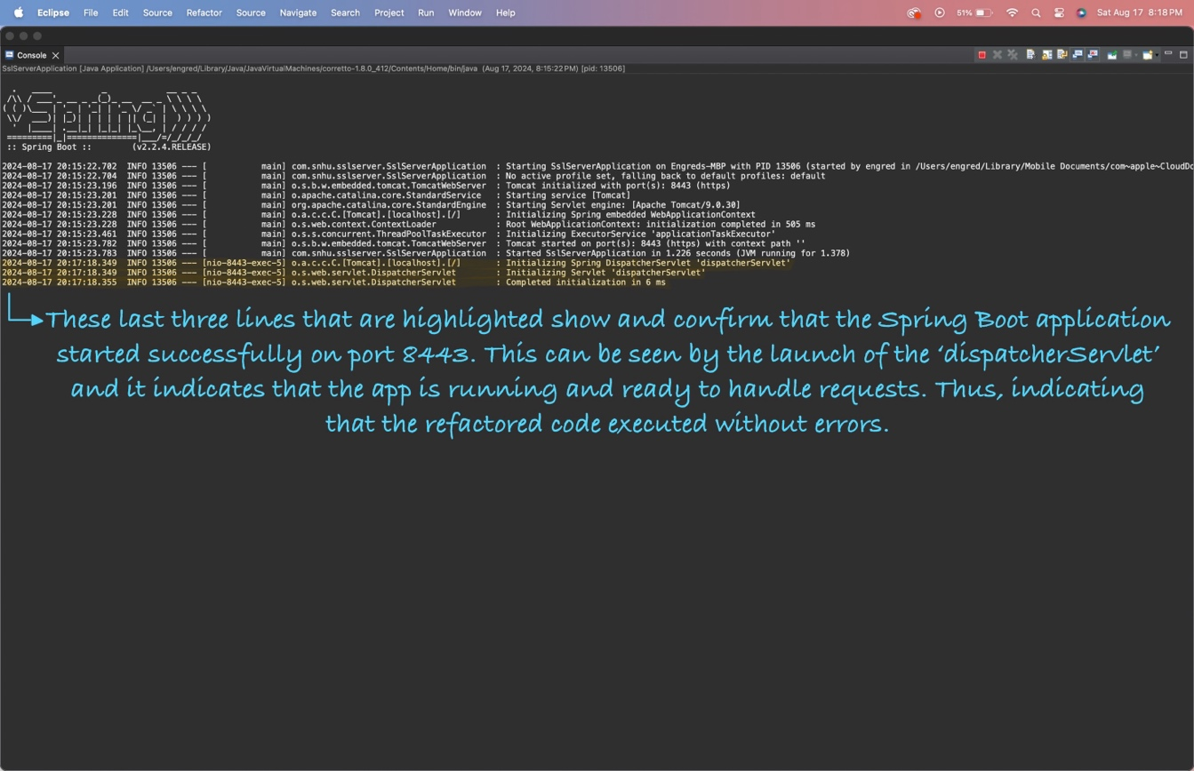
Diagrams showcasing maven build and running java application:
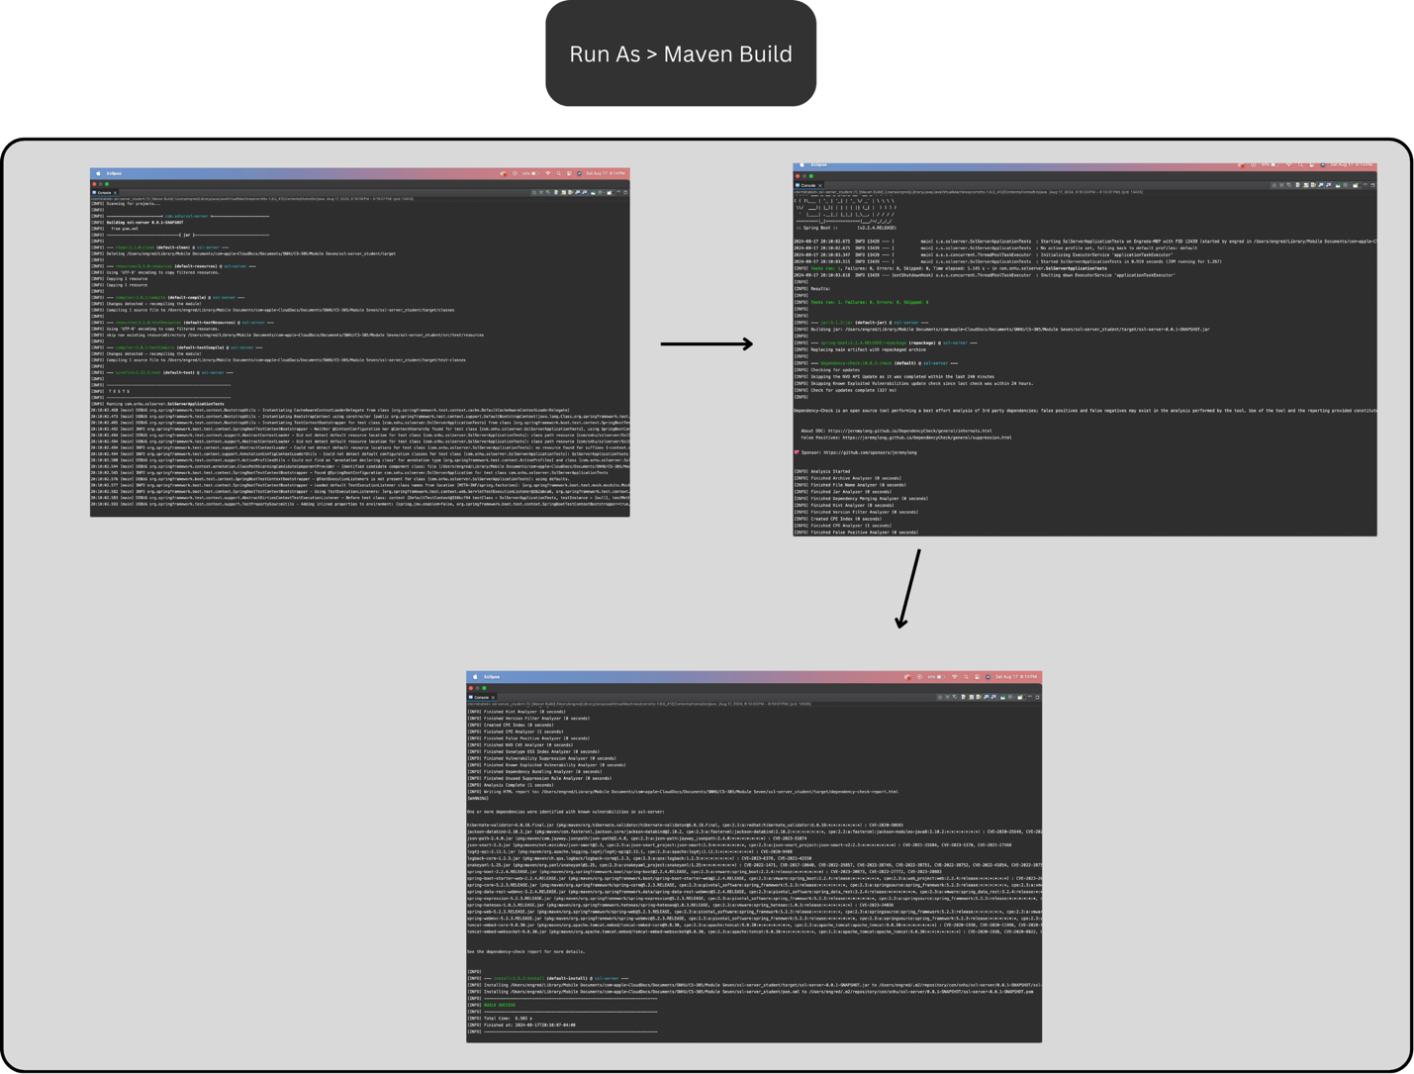

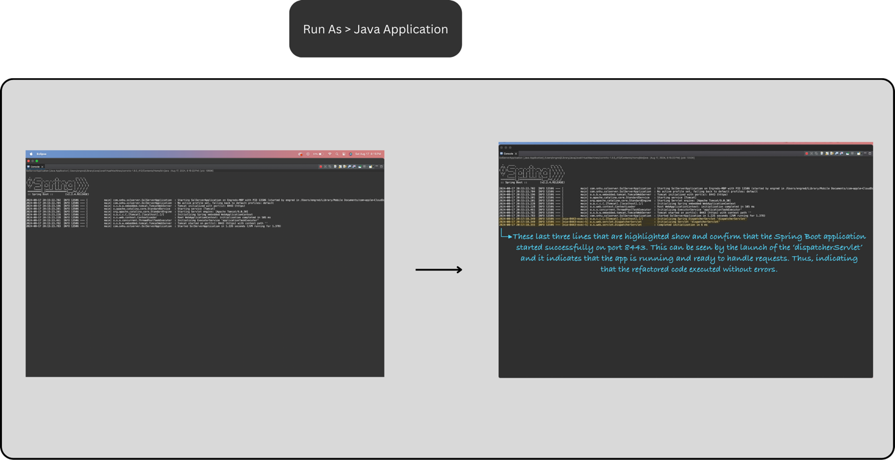

- A screenshot of the dependency-check report after the refactored code:
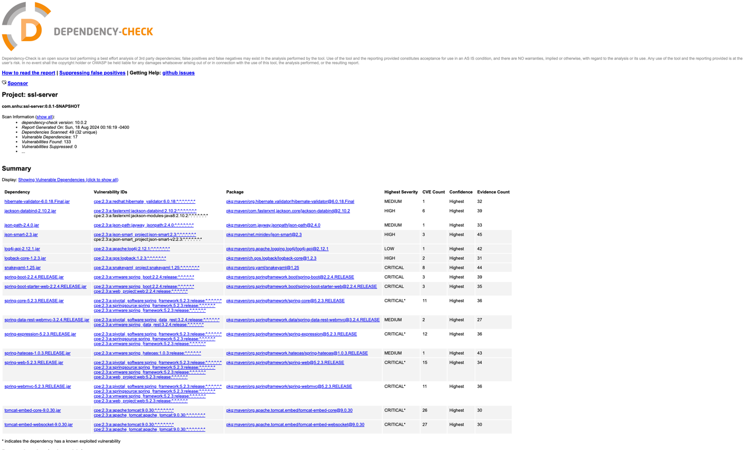

Link: file:///Users/engred/Library/Mobile%20Documents/com~apple~CloudDocs/Documents/SNHU/CS-305/Module%20Seven/ssl-server_student/target/dependency-check-report-AFTER-Refactoring.html

- A screenshot of the dependency-check report before the refactored code:
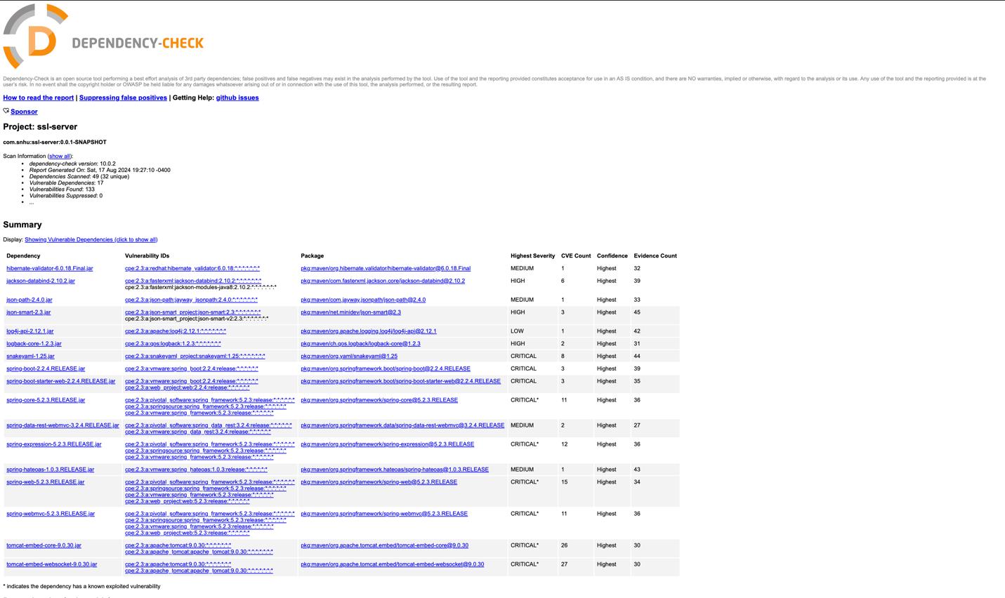

Link: file:///Users/engred/Library/Mobile%20Documents/com~apple~CloudDocs/Documents/SNHU/CS-305/Module%20Seven/ssl-server_student/target/dependency-check-report-BEFORE-Refactoring.html

- A screenshot of the dependency-check report after refactored code and updating libraries and dependencies:
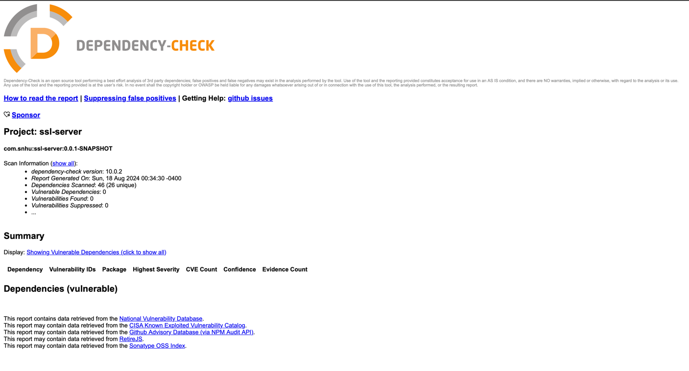
I had to override the Spring Framework version in the Spring Boot dependency management in order to address CVE-2024-38809. Since Spring Boot version 3.3.2 bundles Spring 6.1.11 which is affected by CVE-2024-38809 and the recommendation was to upgrade to version 6.1.12.
Link: file:///Users/engred/Library/Mobile%20Documents/com~apple~CloudDocs/Documents/SNHU/CS-305/Module%20Seven/ssl-server_student/target/dependency-check-report-After-Updating-Dependencies-Libraries.html

Functional Testing
Insert a screenshot below of the refactored code executed without errors.
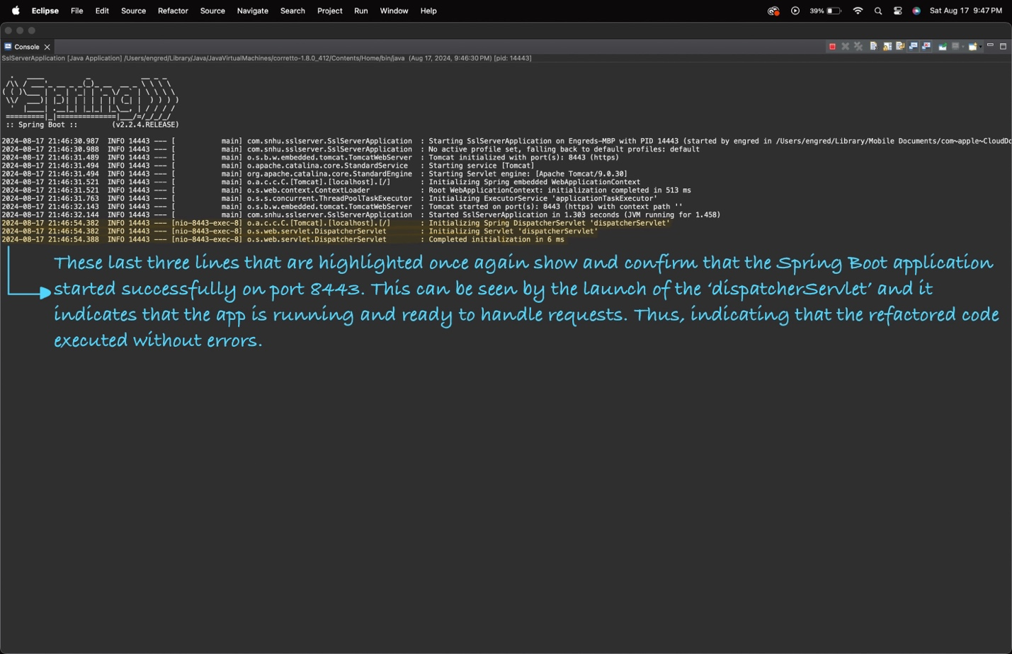

- Syntactical Vulnerabilities

No syntax errors/vulnerabilities were found in any of the codebase files.

- Logical Vulnerabilities

No logical vulnerabilities were found in any of the codebase files since it seems that the application logic is correctly implemented.

- Security Vulnerabilities

‘SHA-256’ use for hashing and SSL configuration in the ‘application.properties’ file are both secure and has been proven when loaded on the browser. I would say that the only minor concern I have regarding security vulnerabilities would be regarding the storage of the keystore password in the ‘application.properties’ file since it is hardcoded here. Ideally, in a production environment, this password would be externalized into another secure environment variable or configuration management tool in order to avoid exposing this sensitive data that attackers can exploit in the codebase.

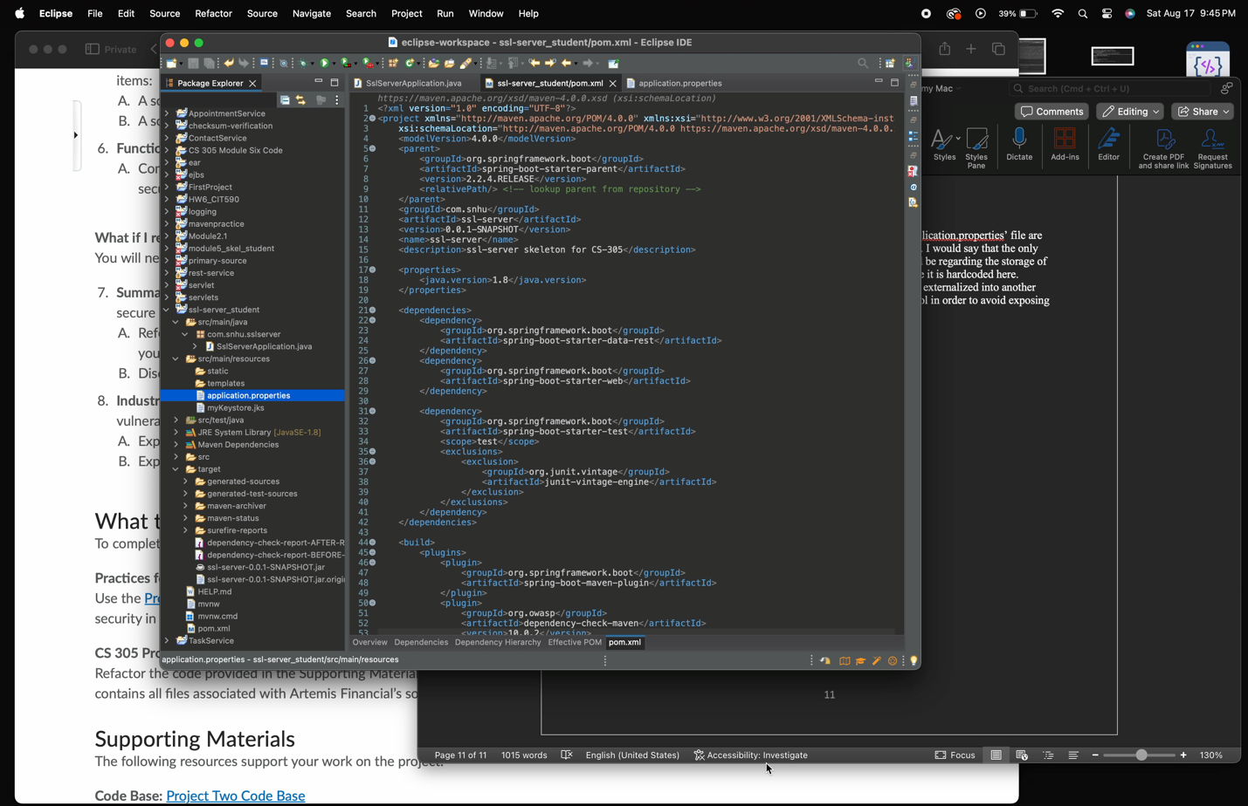
Video showing steps (Double click on image to play):

Summary

- The areas of security that I addressed by refactoring the code were those of encryption and secure communication protocols. While referring to the vulnerability assessment process flow diagram, I focused on the following:
- Cryptography
I Implemented the SHA-256 hash function in order to be able to securely generate checksums for data integrity verification.

- Client/Server
I went ahead and secured the server-client communication by configuring HTTPS with a self-signed certificate.

- Code Quality
I ensured that I maintained code quality by performing proper execution handling to the best of my ability.

I believe that with all of these security measures that I added help ensure not only that the data integrity is preserved, but also that communications are encrypted. Thus, mitigating any potential vulnerabilities that may want to arise.

- My process for adding layers of security to the software application involved various steps that in my opinion collectively fortified the application against any common vulnerabilities. In this case, more specifically focused on those related to data integrity and secure communication. These involved:
- Algorithm selection (algorithm cipher)
Again, I chose the SHA-256 hash function due to its robustness and its widespread use in the industry as being the gold standard.

- Certificate generation
I created a self-signed certificate in order to be able to enable HTTPS and thus ensuring an encrypted communication.

- Configuration (deploying cipher and establishing secure communications)
I went ahead and deployed the cipher (checksum verification), uploaded the ‘myKeystore.jks to the codebase’s resources folder, and updated the ‘application.properties’ file in order to enforce HTTPS on the server.

- Static analysis (secondary testing)
I ran a dependency-check report in order to ensure that I did not introduce any new vulnerabilities into the codebase after adding the checksum verification (refactoring) and enforcing HTTPS.

- Testing (Functional and static testing)
I conducted both functional and static testing to ensure that the refactored code does indeed operate securely and did not introduce any new errors or vulnerabilities onto the codebase.

Industry Standard Best Practices

- I used industry standard best practices to maintain the software application’s existing security by using a strong cryptographic algorithm, in this case, SHA-256. I implemented SHA-256 in the checksum verification in order to ensure the codebase’s data integrity. I also implemented a secure communication protocol through the enforcement of HTTPS by using SSL/TLS, which is a fundamental practice in securing web traffic.
Another thing I did was configure the ‘application.properties’ file to ensure that the SSL/TLS was set up correctly and maintained a secure server-client communication. As this aligns with best practices for web application security.
Lastly, I decided to update the dependencies and libraries used in the codebase although it wasn’t explicitly stated in the assignment requirements but thought it should be done in order to reduce any potential security risks the app may have due to its vulnerabilities. As addressing these vulnerabilities is all a part of secure software development practices in the end and it serves to also not only get more exposure and practice but also helps in becoming a habit to do.

- The value of applying industry standard best practices for secure coding to the company’s overall well-being is obtaining and maintaining the customers trust as it demonstrates a serious commitment to security. Which in turn enhances the customers trust and creates loyalty to the company’s services and products and this is crucial for the company’s long-term success.

A second thing would be efficiency since following best practices not only helps in preventing security issues but also enables the prevention of these security issues early on in the development cycle. Which in turn reduces the cost, resources, time, and effort that is required to address these same vulnerabilities later on.

An extremely important aspect is the company’s ability to significantly reduce its risk of data breaches, financial losses, and reputational damage just by simply adhering to the industry’s best practices. Finally, when a company meets regulatory requirements and standards, such as GDPR, they also ensure that they avoid any legal penalties and consequences.

References
Spring.io. (2024). Spring Framework releases fixes for CVE-2024-38808 and CVE-2024-38809. Spring. https://spring.io/blog/2024/08/14/spring-framework-releases-fixes-for-cve-2024-38808-and-cve-2024-38809

